
The House of Hackers
Pakistan Cyber Security Learning
LAB REPORT

Linux Fundamentals for Cyber security
Lab 1

Lab Title: Linux Hand-on-Practice
Course Title: 60-Day Ultimate Hacking Course [2025]

Student Name: NOOR UL NISA
Learning Through: The House of Hackers — YouTube
Date of Submission: 25 July 2025

Submitted To

Instructor Name: SYED RAMZAN BUKHARI

YouTube Channel: The House of Hackers

Linkndin: Syed Ramzan Bukharii

🧪 Linux Lab Manual: Basic File & Directory Commands
🎯 Lab Objectives
- Understand and use essential Linux commands for file and directory management.
- Practice real-world scenarios using CLI.
- Learn command syntax, purpose, and output interpretation.
- Enhance confidence in navigating and manipulating Linux file systems.
🔰 Lab 1: Listing Files — ls
📌 Purpose: List contents of a directory
📘 Syntax: ls [options] [directory]
🔍 Example: ls -l /home
📤 Expected Output: Lists all files in /home with details.
✅ Try These Exercises:
- List all files in your current directory.
- Use ls -a to show hidden files.
- Use ls -lh /etc to show human-readable file sizes.
📸 Insert Screenshot Here
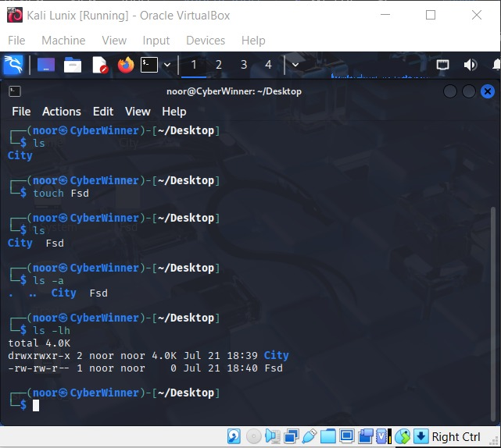
🔰 Lab 2: Changing Directories — cd
📌 Purpose: Move between directories
📘 Syntax: cd [directory]
🔍 Example: cd /etc
📤 Expected Output: Terminal changes to /etc.
✅ Try These Exercises:
- Move to your home directory using cd ~.
- Navigate to /var/log.
- Use cd .. to move one directory up.
📸 Insert Screenshot Here
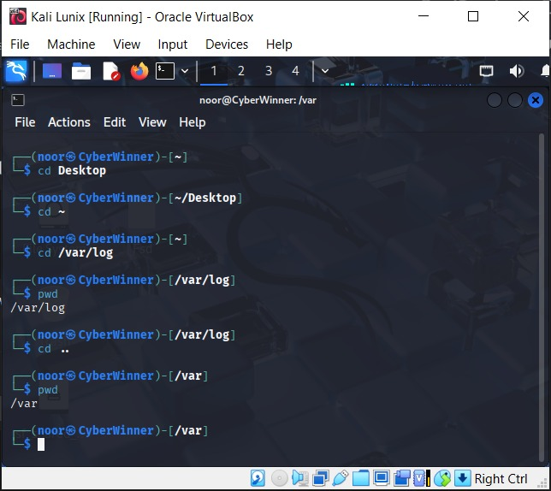
🔰 Lab 3: Show Current Directory — pwd
📌 Purpose: Display current working directory
📘 Syntax: pwd
🔍 Example: pwd
📤 Expected Output: Absolute path of the current directory.
✅ Try These Exercises:
- Run pwd after navigating to /usr/bin.
- Compare the output with what’s shown in the prompt.
📸 Insert Screenshot Here
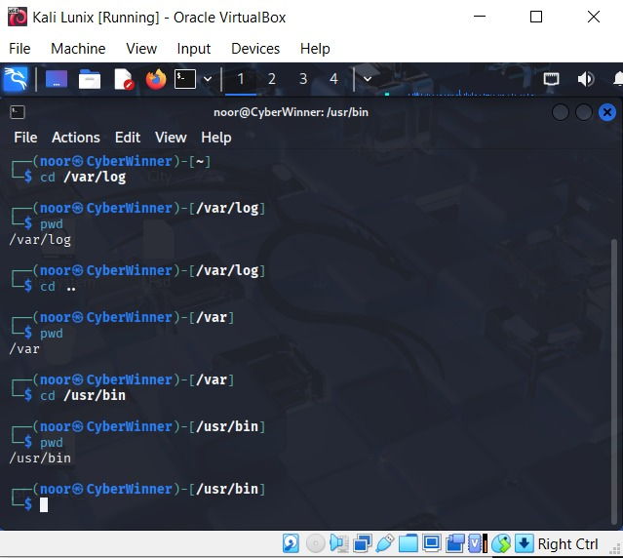
🔰 Lab 4: Create Directories — mkdir
📌 Purpose: Make new directory
📘 Syntax: mkdir [dirname]
🔍 Example: mkdir new_folder
📤 Expected Output: A directory named new_folder is created.
✅ Try These Exercises:
- Create a folder named Projects.
- Create nested folders using mkdir -p Work/Reports/2025.
📸 Insert Screenshot Here
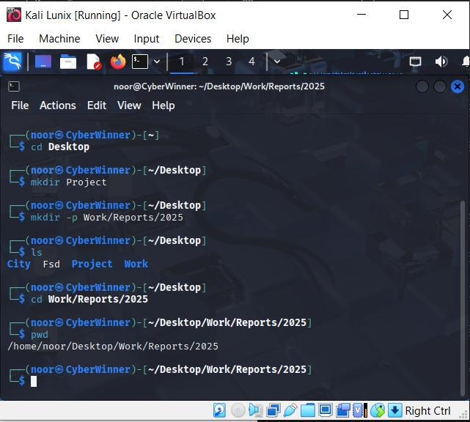
🔰 Lab 5: Remove Empty Directories — rmdir
📌 Purpose: Delete empty directories
📘 Syntax: rmdir [dirname]
🔍 Example: rmdir old_folder
📤 Expected Output: Directory is deleted if it’s empty.
✅ Try These Exercises:
- Create a folder Temp and delete it using rmdir.
- Try deleting a non-empty folder and observe the error.
📸 Insert Screenshot Here
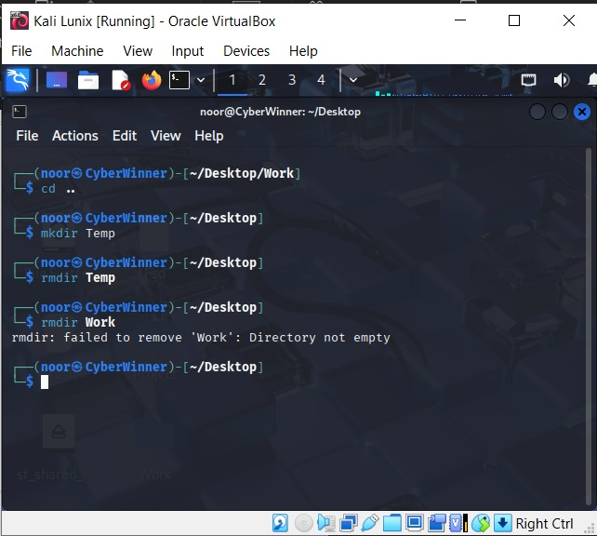
🔰 Lab 6: Create Files — touch
📌 Purpose: Make empty files
📘 Syntax: touch [filename]
🔍 Example: touch file.txt
📤 Expected Output: A new empty file is created.
✅ Try These Exercises:
- Create a file named hello.txt.
- Create multiple files at once: touch a.txt b.txt c.txt.
📸 Insert Screenshot Here
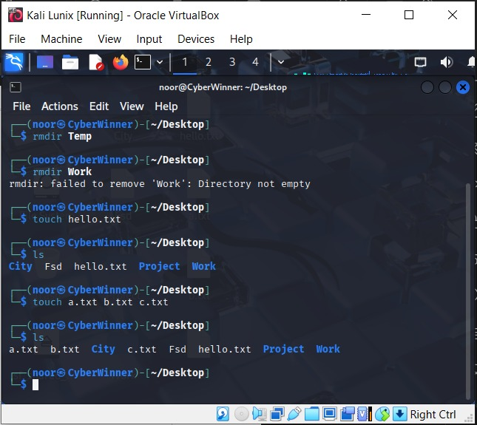
🔰 Lab 7: Remove Files/Dirs — rm
📌 Purpose: Delete files/directories
📘 Syntax: rm [options] [target]
🔍 Example: rm -rf folder
📤 Expected Output: Folder and contents deleted.
✅ Try These Exercises:
- Create and delete a file.
- Create a folder with files and delete it using rm -r.
⚠️ Warning: Use rm -rf carefully.
📸 Insert Screenshot Here
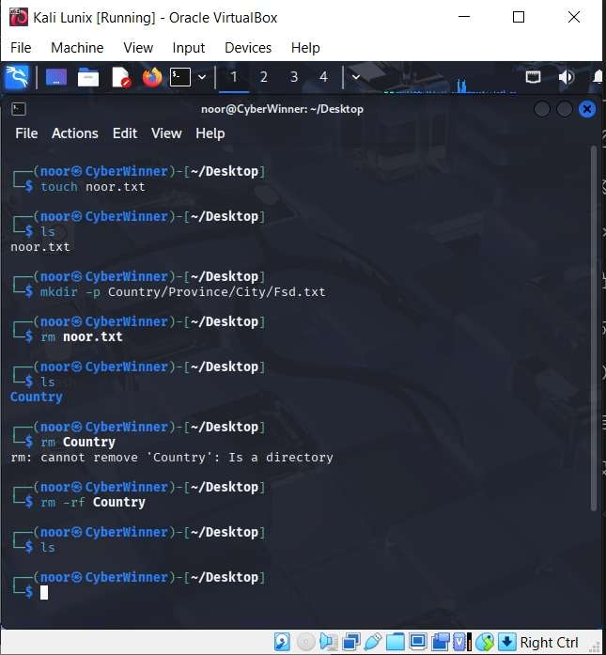
🔰 Lab 8: Copy Files — cp
📌 Purpose: Copy files or folders
📘 Syntax: cp [source] [destination]
🔍 Example: cp file.txt backup/
📤 Expected Output: File is copied.
✅ Try These Exercises:
- Copy hello.txt to a new folder.
- Use cp -r to copy a directory.
📸 Insert Screenshot Here
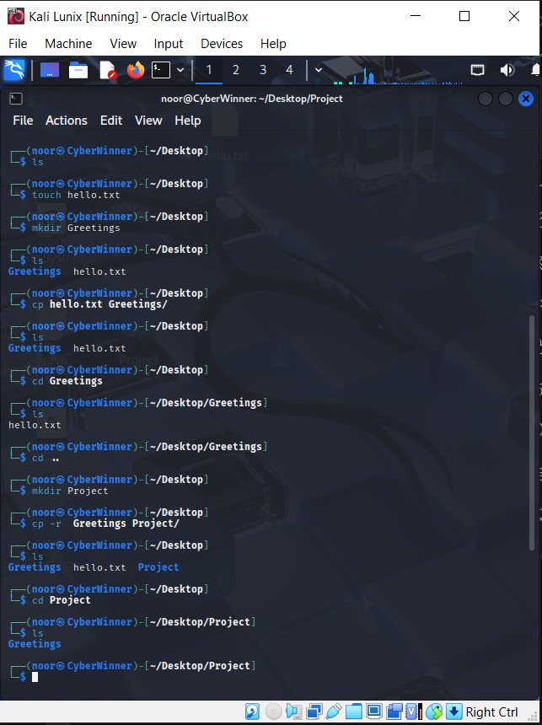
🔰 Lab 9: Move or Rename — mv
📌 Purpose: Move or rename files
📘 Syntax: mv [source] [destination]
🔍 Example: mv old.txt new.txt
📤 Expected Output: File renamed or moved.
✅ Try These Exercises:
- Rename a.txt to alpha.txt.
- Move alpha.txt into Documents/.
📸 Insert Screenshot Here
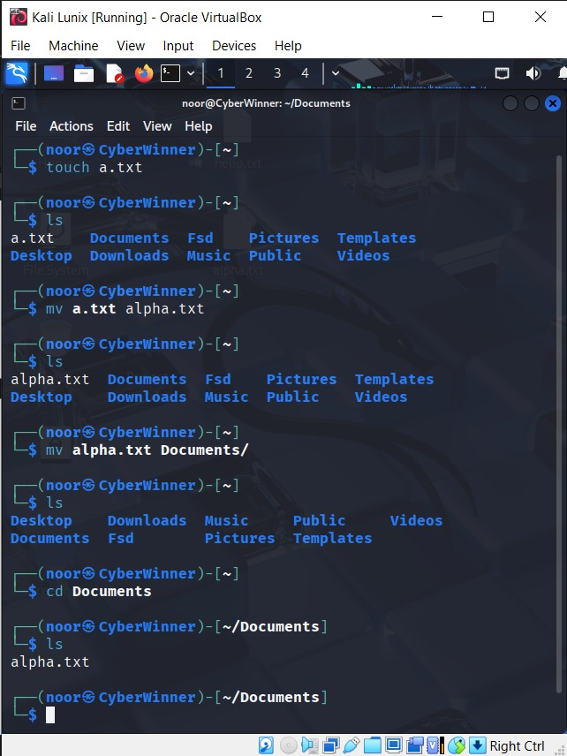
🔰 Lab 10: File Information — stat
📌 Purpose: View metadata of file
📘 Syntax: stat [file]
🔍 Example: stat file.txt
📤 Expected Output: Shows size, permissions, modification time, etc.
✅ Try These Exercises:
- Check the info of file.txt.
- Observe size changes after editing the file.
📸 Insert Screenshot Here
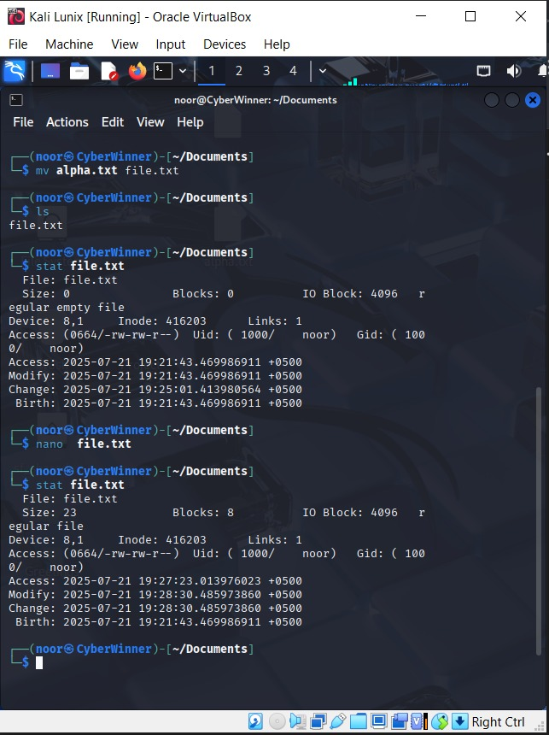
🔰 Lab 11: Identify File Type — file
📌 Purpose: Determine file type
📘 Syntax: file [filename]
🔍 Example: file script.sh
📤 Expected Output: Shows if it's ASCII, script, image, etc.
✅ Try These Exercises:
- Run file on text, PDF, and image files.
- Use file on a binary executable.
📸 Insert Screenshot Here
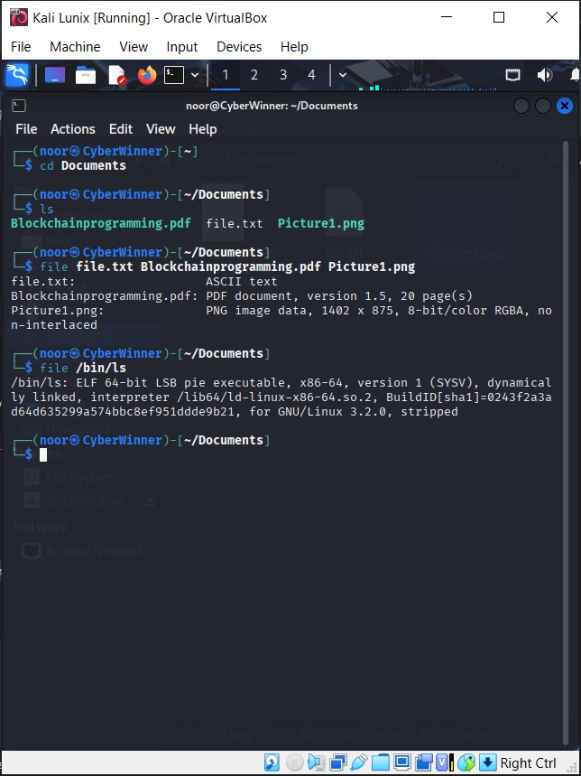

🔰 Lab 12: Get Filename Only — basename
📌 Purpose: Extract file name from path
📘 Syntax: basename [path]
🔍 Example: basename /home/user/file.txt
📤 Expected Output: file.txt
✅ Try These Exercises:
- Extract basename of various paths.
📸 Insert Screenshot Here
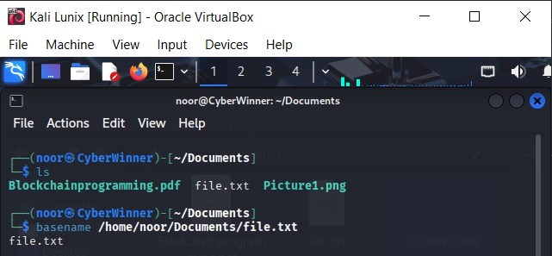
🔰 Lab 13: Get Directory Name — dirname
📌 Purpose: Extract directory path
📘 Syntax: dirname [path]
🔍 Example: dirname /home/user/file.txt
📤 Expected Output: /home/user
✅ Try These Exercises:
- Use dirname on absolute paths.
- Combine dirname and basename in one command.
📸 Insert Screenshot Here
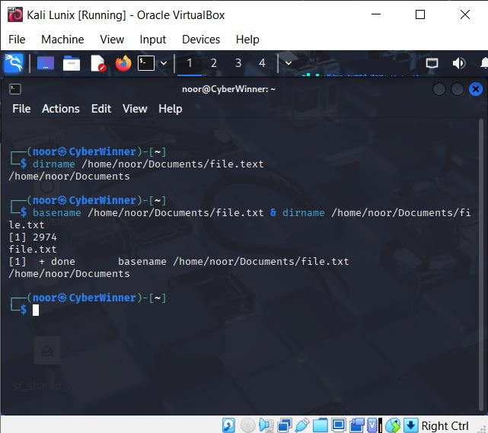
📚 Final Task: Real-World Scenario Practice
Perform these tasks as a complete practice:
- Create a directory LinuxLab and enter it.
- Create files test1.txt, test2.txt.
- Copy them to backup/.
- Rename test1.txt to report.txt.
- Delete test2.txt.
- View file details using stat and type using file.
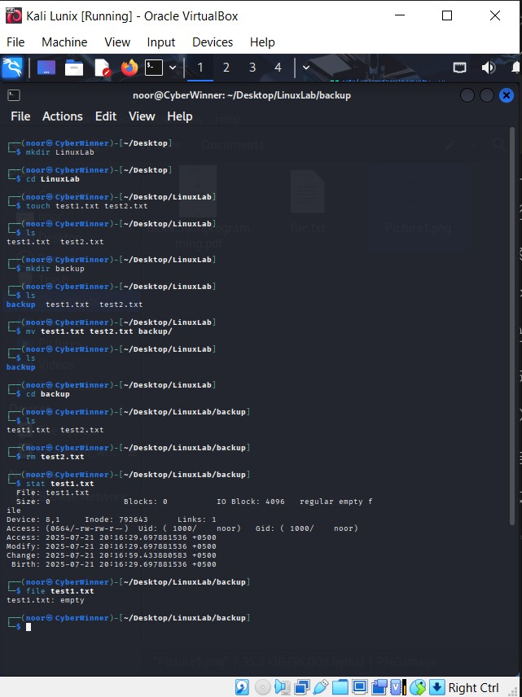
📝 Notes:
- Always double-check before using rm -rf.
- Practice using absolute (/home/user) and relative (../folder) paths.
- These basics are foundational for advanced Linux and scripting tasks.

